Instrument Modification of the *Salmonella PCR* Assay

Instrument Modification of the Salmonella PCR Assay from Cephid Smartcycler to ABI7500 Fast

Authors:

Erin Peterson, Principal Microbiologist

George Dickinson, Principal Microbiology

Robert Voermans, Microbiology Section Manager

Mathew Burns, Developmental Scientist

# Introduction

As of December, 2018, Cepheid Inc. will no longer be providing maintenance, support, parts and/or accessories for the Smartcycler Instruments. IBL currently operates a considerable number of PCR assays on these Smartcycler units and will start the processes of moving these assays to different rt-PCR platforms that continue to have manufacturer support. The *IBL Salmonella* rt-PCR Assay ,which detects OriC-like DNA sequences specific to *Salmonella*, is currently validated on the Smartcycler Instrument. We would like to move this assay to the Applied Biosystems® 7500 Fast Dx Real-Time PCR Instrument (ABI 7500).

Here we demonstrate that there is no substantial loss in detection, increase in false positives or other substantive differences, for *Salmonella* assays carried out on the ABI 7500, as compared to the Smartcycler. We assessed the performance of the ABI 7500 by running parallel assays for ten DNA extracts - from salmonella and other (‘non-salmonella’) bacteria cultures - on both machines under identical conditions and analyzed the results to determine if any such differences were observed. Furthermore, we quantified the limit of detection for the ABI 7500 by serially diluting one of the salmonella DNA extracts, showing that OriC-like DNA could be detected in samples containing as little as 0.03 ng/ml total DNA (a 1:100,000 dilution of the original sample).

## Definitions

***PCR****: polymerase chain reaction, a method of replicating a specific DNA sequence.*

***ABI 7500****: Applied Biosystems® 7500 Fast Dx Real-Time PCR Instrument.*

***Rt-PCR****: real time polymerase chain reaction, a variant of PCR in which amplified DNA products are detected over the course of the reaction – leading to improved quantitation of the amplified DNA.*

***OriC****: replication origin, area of bacterial genome that signals for the origin of replication.*

***gfp****: green fluorescent protein, the gfp gene is commonly used in in molecular biology as a reporter of expression.*

# Methods/Materials

In order to test the performance of the ABI 7500, DNA extracts from ten *Salmonella* spp. serotypes and tencommon bacterialpathogens were serially diluted, split and run in parallel on both systems under identical conditions. Parallel runs were performed on the same day, in the same lab, with appropriate controls (a negative control without a DNA template, a positive control with a *Salmonella* DNA template and a *gfp* DNA template internal control added to all samples). The cycle threshold (ct) limits for both the target (*OriC*) and the internal control (IC) were compared to determine if any differences in dection, or generation of false positives, could be observed.

The methodology generally followed the protocols decribed in the SOP for The Detection of *Salmonella spp.* DNA by multiplex rt-PCR from Food, Bacterial Isolates and Environmental Samples – however, after an initial trial the ABI 7500 reaction conditions were modified (the anealing and elongation step times were increased from 10 to 20 s) to account for a slight differnce in instrument performance. In brief, the method was as follows:

1. DNA samples were prepared from isolated colonies of the ensuing bacteria (following SOP DNA Extraction guidelines):
2. 10 *Salmonella* spp. serotypes (i.e. ***S. enterica, S. typhimurium, S. Irumu, S. newport, S. infantis,* S*. 4,[5],12:i:-, S. montevideo, S. cerro, S. hadar and S. muenchen***)
3. 10 OriC assay negative bacterial pathogens (i.e. ***Escherichia coli, Pseudomonas aeruginosa, Enterobacter cloacae, Shigella flexneri, Shigella sonnei, Stenotrophomonas maltophilia, Proteus mirabilis, Morganella morganii, Citrobacter freundii, Citrobacter freundii* complex**)

The samples were serially diluted (1:10, 1:100 and 1:1000 dilution) either used immediately or frozen, stored at -20 oC and thawed immediately prior to use.

1. A common mastermix containing the necessary reagents, primers (P1_F, P3_R, gfp_F and gfp_R) and probes (OriC214_P and gfp_P) was prepared. 20 µL of the mastermix was added to the PCR reaction tubes (SmartCycler) or a 96-well plate (ABI 7500) and then 5 µL of sample (for a total volume of 25 µL per reaction). Aliquots taken from the same samples were run on both systems for all dilutions. The reaction tubes and 96-well plates were then sealed, centrifuged and placed in the appropriate machine for the PCR reaction.
2. The assay were run in parallel on both the SmartCyler, using the preset “Salmonella” protocol as defined in the SOP, and the ABI 7500. Parallel experiments were carried out on the same day, as close in time as was practical to keep conditions as similar as possible. Initially the ABI 7500 was run using identical parameters to the SmartCyler – but after optimization the annealing and elongation step times were increased to 20 s. All data described in this report was generated using these longer step times.
3. Once the assays were completed the fluorescence thresholds for the target (*OriC*) and IC were examined for all of the samples at their various diltiuons and the controls to determine whether the amplification of target DNA and/or the IC was observed.

# Results and Discussion

Typically, the sensitivity of assays based on rt-PCR reactions are mainly influenced by sample quality - that is the quality and amount of the DNA extracted and the presence of PCR inhibitors and/or auto-fluorescent compounds capable of interfering with amplification and detection of DNA – not the instrumentation used to carry out the assay. As such, it was not anticipated that the ABI 7500 would give substantially different results to the SmartCycler, and this indeed is the case. Figure 1 plots the ct values for all the DNA extracts and their dilutions for both the *OriC* and *gfp* assays. In all cases both the target DNA and the *gfp* IC were detected by both machines – with almost identical results for the *OriC* assay (due to experimental error the 1:1000 dilution was lost for the muenchen ABI 7500 sample). The consistently lower ct values obtained for gfp with the ABI 7500 suggest that it may actually demonstrate increased sensitivity and better reproducibility to the SmartCycler for some assays.

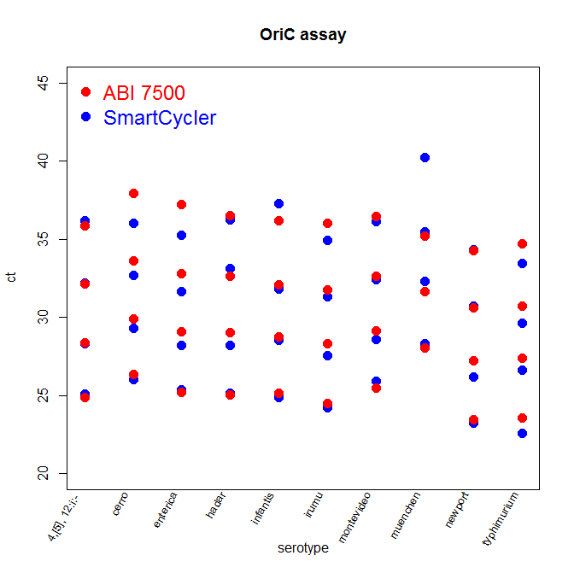 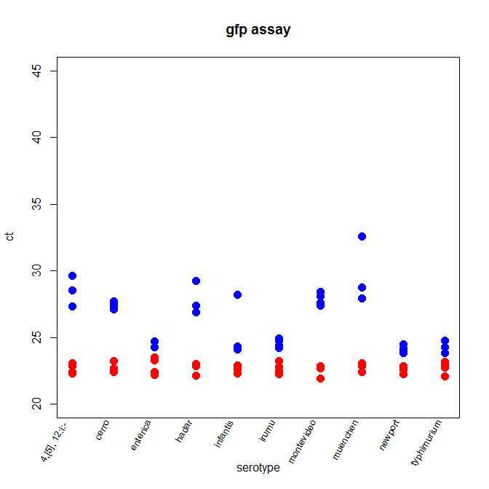

**Figure 1. The ABI 7500 demonstrates similar performance to the SmartCycler in detecting OriC**

Serially diluted DNA extracts from ten salmonella serotypes were assayed for OriC and gfp in parallel on both PCR machines. The ct values for each serotype are plotted for the ABI 7500 (red circles) and the SmartCycler (blue circles) with all four dilutions (undiluted, 1:10, 1:100 and 1:1000) shown in each column.

Replotting the data as a scattergraph of ct values against dilution (**Fig 2**) highlights the similarity in performance and sensitivity for the *OriC* assay between machines. Both machines report a consistent increase in ct values over a 1000-fold dilution range (approximately 4 cycles per 10 fold dilution), as expected, with no corresponding change in *gfp* detection.

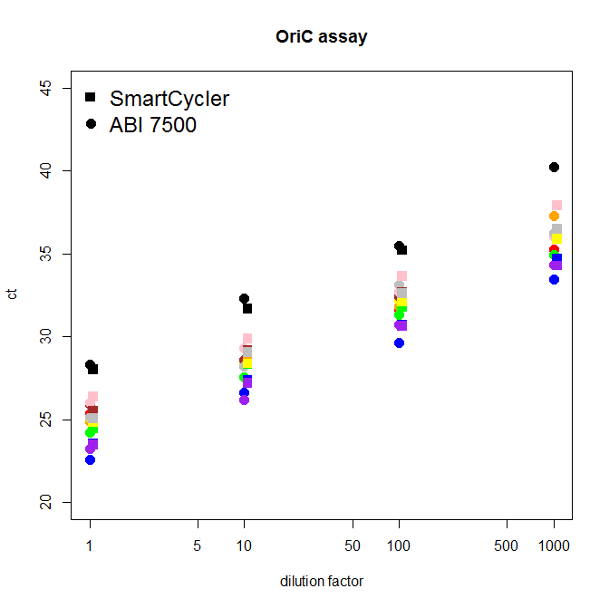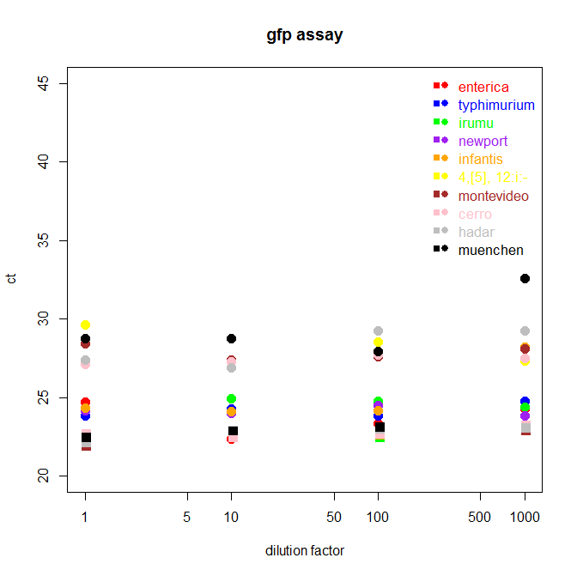

**Figure 2 The ABI 7500 demonstrates similar sensitivity to the SmartCycler over a 1000-fold dilution range.**

Serially diluted DNA extracts from ten salmonella serotypes were assayed for OriC and gfp in parallel on both PCR machines (same data as Fig 1). The ct values for each serotype are plotted for the ABI 7500 (filled circles) and the SmartCycler (filled squares) against dilution (x-axis on a log scale). Each serotype is plotted as a different color.

In order to test whether the ABI 7500 generates false positives we also performed the *OriC*/*gfp* assays on DNA extracts from ten different bateria cultures (non-salmonella). Once again, as demonstrated in Figure 3, both machines performed similarly with no *OriC* amplification detected in any of the samples. As with the salmonella experiements, the ABI 7500 displayed an increased sensitivity to the SmartCycler for *gfp* detection.

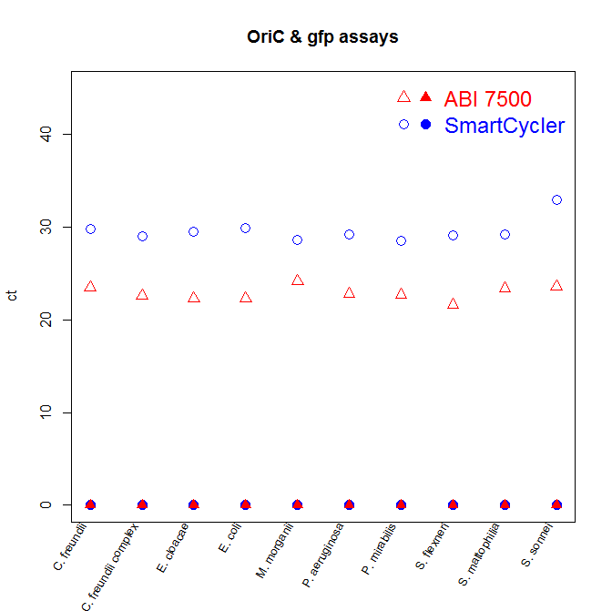

**Figure 3. *OriC* amplification was not detected in ‘non-salmonella’ bacteria by either the ABI 6500 or the SmartCycler.**

DNA extracts from ten different bacteria cultures were assayed for *OriC* (filled symbols) and *gfp* (open symbols) in parallel on both PCR machines. The ct values for each sample are plotted for the ABI 7500 (red) and the SmartCycler (blue).

As an additional test we also examined the limit of detection for *OriC* for the ABI 7500. To accomplish this we serially diluted one of the salmonella samples (***S. enterica***) over a greater range (up to 1:108) and tested the dilutions for *OriC* amplication, as described above. The total amount of DNA in the samples was estimated using a NanoDrop spectrophotometer to quantify the DNA in the undiluted sample (2.9 µg/ml) and calculating the expected amount for each dilution. Figure 4 plots the ct values for the various dilutions (plotted on a log scale). As seen in Fig 2 when plotted on a log scale there is a linear realtonship between the increase in ct and the amount of dilution over this range. The assay was performed in duplicate on the same samples with similar results. In one case *OriC* detection was seen in a 1:1000,000 dilution (containing approximately 0.03 ng/ml total DNA).

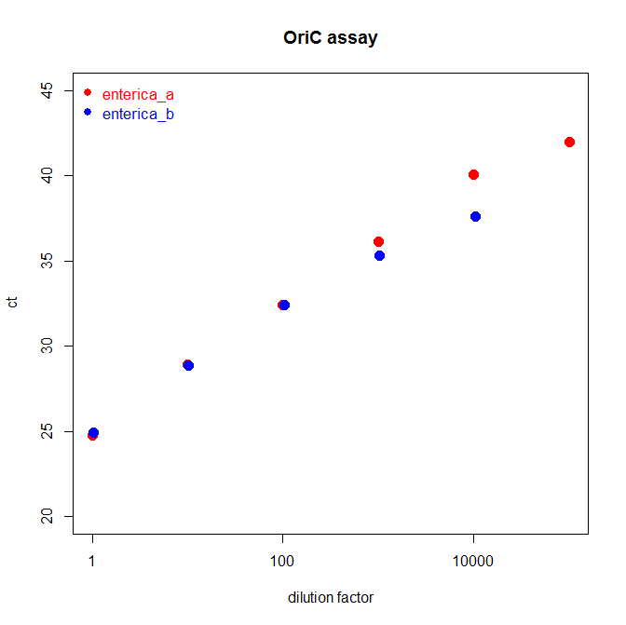

**Figure 4. The ABI 7500 detected *OriC* amplification in a salmonella DNA extract diluted up to 1:1000,000.**

Serially diluted DNA extracts from *S. enterica* up to a dilution of 1:108 were assayed for *OriC* on the ABI 7500. Duplicate runs were performed and the ct values for the *OriC* assay are plotted here for samples in which *OriC* amplification was detected. Internal control (*gfp*)amplification was detected as expected in all samples (data not shown).

# Conclusion

Given that modifications to the method are unlikely we propose that a simple parallel study be conducted as described above and that should the results of the study show no discernable difference in switching platforms, that the method modification be approved on the merits of the parallel study alone.

# References

[Current Method SOP]

# Supplemental Information

|  |  |  |  |  |  |  |  |  |  |  |  |  |  |  |  |  |
| --- | --- | --- | --- | --- | --- | --- | --- | --- | --- | --- | --- | --- | --- | --- | --- | --- |
|  | **SmartCycler** | | | | | | | | **ABI 7500** | | | | | | | |
|  | ***OriC*** | | | | ***GFP*** | | | | ***OriC*** | | | | ***GFP*** | | | |
| **Salmonella spp.** | **1:1** | **1:10** | **1:100** | **1:1000** | **1:1** | **1:10** | **1:100** | **1:1000** | **1:1** | **1:10** | **1:100** | **1:1000** | **1:1** | **1:10** | **1:100** | **1:1000** |
| *enterica* | 25.38 | 28.19 | 31.64 | 35.23 | 24.73 | 22.39 | 23.36 | 24.28 | 25.2 | 29.1018 | 32.8037 | 37.2037 | 22.1882 | 22.4293 | 23.317 | 23.5224 |
| *typhimurium* | 22.58 | 26.61 | 29.64 | 33.46 | 23.83 | 24.25 | 23.82 | 24.75 | 23.5602 | 27.388 | 30.699 | 34.6879 | 22.0732 | 22.7436 | 22.9821 | 23.1765 |
| *irumu* | 24.2 | 27.55 | 31.32 | 34.95 | 24.22 | 24.95 | 24.78 | 24.36 | 24.466 | 28.341 | 31.7757 | 36.0068 | 22.2464 | 22.8154 | 22.4586 | 23.2112 |
| *newport* | 23.23 | 26.17 | 30.72 | 34.34 | 24.15 | 23.99 | 24.51 | 23.83 | 23.4715 | 27.2113 | 30.631 | 34.2715 | 22.2656 | 22.5891 | 22.7199 | 22.8615 |
| *infantis* | 24.86 | 28.52 | 31.81 | 37.29 | 24.34 | 24.12 | 24.15 | 28.22 | 25.1414 | 28.7304 | 32.0971 | 36.1676 | 22.3003 | 22.6304 | 22.6128 | 22.8974 |
| *4,[5], 12:i:-* | 25.09 | 28.29 | 32.19 | 36.17 | 29.6 | 27.32 | 28.51 | 27.36 | 24.8543 | 28.371 | 32.1124 | 35.8733 | 22.3114 | 22.4367 | 22.8488 | 23.0806 |
| *montevideo* | 25.93 | 28.61 | 32.42 | 36.14 | 28.45 | 27.39 | 27.59 | 28.09 | 25.4987 | 29.1544 | 32.6437 | 36.461 | 21.9088 | 22.7137 | 22.7059 | 22.85 |
| *cerro* | 26.04 | 29.29 | 32.69 | 36.03 | 27.12 | 27.26 | 27.7 | 27.52 | 26.3656 | 29.8812 | 33.6275 | 37.9067 | 22.6734 | 22.4442 | 22.6335 | 23.2201 |
| *hadar* | 25.16 | 28.2 | 33.14 | 36.24 | 27.37 | 26.88 | 29.26 | 29.22 | 25.0536 | 29.0527 | 32.6122 | 36.4998 | 22.1203 | 22.8639 | 22.9691 | 23.0376 |
| *muenchen* | 28.29 | 32.32 | 35.49 | 40.25 | 28.75 | 28.77 | 27.92 | 32.6 | 28.0203 | 31.6686 | 35.1989 | None | 22.4277 | 22.855 | 23.0996 | -------- |

|  |  |  |  |  |  |  |
| --- | --- | --- | --- | --- | --- | --- |
|  | **SmartCycler (samples 1-5)** | | **SmartCycler (samples 6-10)** | | **ABI 7500 (samples 1-10)** | |
|  | ***OriC*** | ***GFP*** | ***OriC*** | ***GFP*** | ***OriC*** | ***GFP*** |
| **Positive Control** | 30.03 | 23.19 | 30.06 | 33.22 | 30.4976 | 21.9624 |
| **NTC** | 0 | 22.54 | 0 | 28.99 | 0 | 22.5627 |

**Table 1. Salmonella spp. ct values for OriC and gfp assays**

|  |  |  |  |  |
| --- | --- | --- | --- | --- |
|  | **SmartCycler** | | **ABI 7500** | |
| **Bacteria** | ***OriC*** | ***GFP*** | ***OriC*** | ***GFP*** |
| *Escherichia coli* | 0 | 29.88 | 0 | 22.2911 |
| *Pseudomonas aeruginosa* | 0 | 29.24 | 0 | 22.8407 |
| *Enterobacter cloacae* | 0 | 29.52 | 0 | 22.3521 |
| *Shigella flexneri* | 0 | 29.09 | 0 | 21.5908 |
| *Shigella sonnei* | 0 | 32.95 | 0 | 23.6302 |
| *Stenotrophomonas maltophilia* | 0 | 29.25 | 0 | 23.3602 |
| *Proteus mirabilis* | 0 | 28.51 | 0 | 22.7452 |
| *Morganella morganii* | 0 | 28.62 | 0 | 24.1818 |
| *Citrobacter freundii* | 0 | 29.8 | 0 | 23.5153 |
| *Citrobacter freundii* complex | 0 | 29.05 | 0 | 22.5894 |

|  |  |  |  |  |
| --- | --- | --- | --- | --- |
|  | **SmartCycler** | | **ABI 7500** | |
|  | ***OriC*** | ***GFP*** | ***OriC*** | ***GFP*** |
| **Positive Control** | 30.02 | 28.6 | 29.5851 | 23.0802 |
| **NTC** | 0 | 28.34 | 0 | 24.0308 |

**Table 2. ‘Non-Salmonella’ ct values for OriC and gfp assays**

|  |  |  |  |  |  |
| --- | --- | --- | --- | --- | --- |
|  |  | **ct** | | | |
|  |  | **duplicate 1** | | **duplicate 2** | |
| **Dilution** | **total DNA (ng/ml)** | **OriC** | **gfp** | **OriC** | **gfp** |
| **1** | 2900.0000 | 24.7441 | 24.6176 | 24.9231 | 25.1521 |
| **10** | 290.0000 | 28.8911 | 26.2434 | 28.8485 | 26.1645 |
| **100** | 29.0000 | 32.4059 | 25.9435 | 32.3956 | 26.3966 |
| **1000** | 2.9000 | 36.1345 | 26.2888 | 35.3033 | 26.2873 |
| **10000** | 0.2900 | 40.061 | 26.1724 | 37.5997 | 26.5653 |
| **100000** | 0.0290 | 41.9576 | 26.2918 |  | 26.2598 |
| **1000000** | 0.0029 |  | 26.1396 |  | 26.2357 |
| **10000000** | 0.0003 |  | 25.4276 |  | 25.7268 |

|  |  |  |
| --- | --- | --- |
|  | **OriC** | **gfp** |
| **Positive control** | 30.0916 | 25.388 |
| **NTC** |  | 25.4436 |

**Table 3. Limit of detection results for ABI 7500**